4. React-JS HOL

Name:- Shubham Sangram Bej

Hands-on 4

Objective
- Understand the React Component Lifecycle.
- Learn the purpose of componentDidMount() and componentDidCatch().
- Fetch data from an external API using the Fetch API.
- Display dynamic data using React Class Components.

Software Requirements
- Node.js
- npm
- React
- Visual Studio Code

Project Name
blogapp

Procedure
- Created a new React application named blogapp.
- Created a model class named Post.js to represent blog posts.
- Created a Class Component named Posts.js.
- Initialized the component state with an empty list of posts.
- Implemented the loadPosts() method using the Fetch API to retrieve posts from:
https://jsonplaceholder.typicode.com/posts
- Implemented the componentDidMount() lifecycle method to invoke loadPosts() after the component was mounted.
- Implemented the render() method to display the title and body of each post.
- Implemented the componentDidCatch() lifecycle method for basic error handling.
- Imported the Posts component into App.js.
- Executed the application using:
npm start
- Verified the output in the browser.

Output
The application successfully fetches blog posts from the online API and displays:
- Post Title
- Post Description (Body)
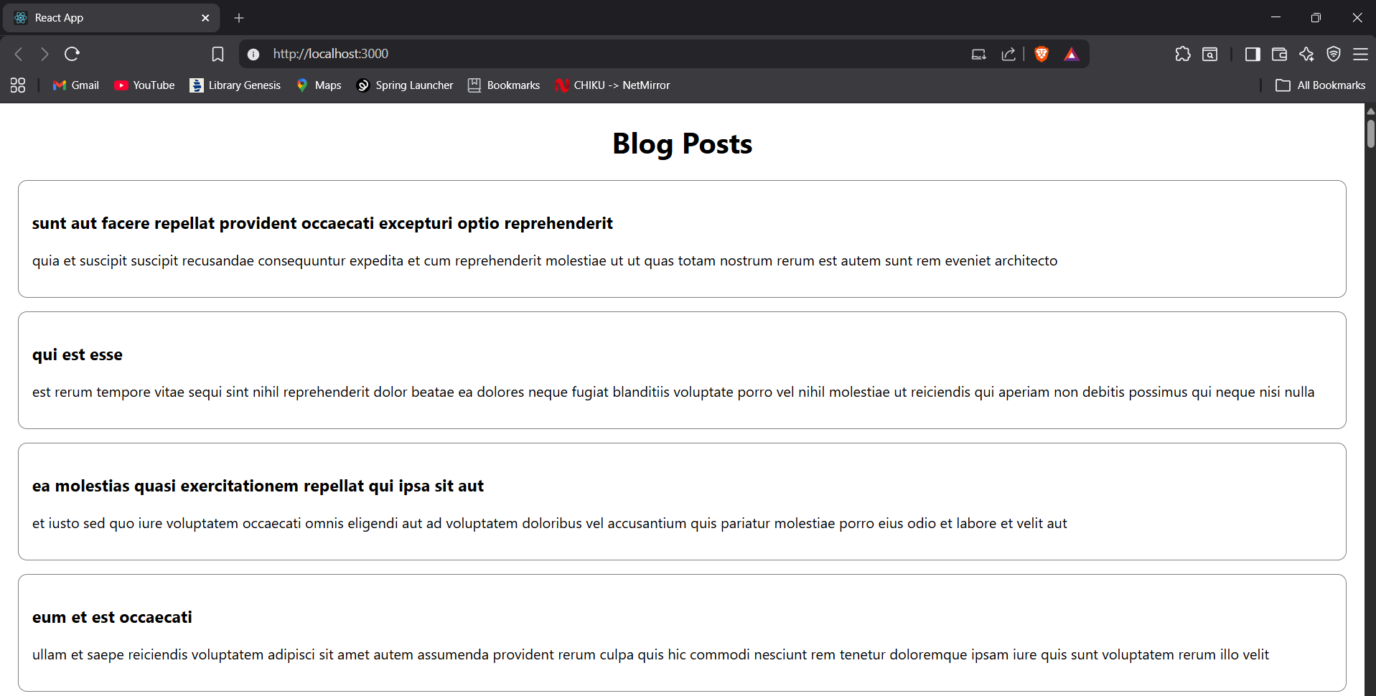

Result
The React application blogapp was successfully created. The componentDidMount() lifecycle method was used to fetch data from a REST API, and the blog posts were displayed successfully using a Class Component.

